

|  |  |
| --- | --- |
| **SANCTION:** | In granting this sanction it is understood and agreed that USA Swimming shall be free from any liabilities or claims for damages arising by reason of injuries to anyone during the conduct of the event. Held under the sanction of USA Swimming, Inc. Sanction #: 2022-037G |
| **MEET HOST:** | Maverick Aquatics and Gunnison Stingrays Swim Club |
| **LOCATION:** | Colorado Mesa University, El Pomar Natatorium, Maverick Center, Elevation 4,592. Corner of 12th St. and Orchard Ave., Grand Junction, CO (970) 248-1592 |
| **FACILITY:** | 10 lane, 50 Meter Indoor Competition pool, limited warm up and cool down area. Water depth is 7 ½ feet to 13 feet. The scoreboard is a Colorado Timing LED Board. Long Course will be converted to 6 lane, 25 yard short course for 8&Under events. Long Course Meters will be swum in 8 or 9 lanes. Lane 10 will be used for warmup/swim down. The competition course has been certified in accordance with 104.2.2c(4). The copy of such certification is on file with USA Swimming.  The lawn area outside the Rec Center desk (southeast of building), will be available for athletes to set up day camps. Pop up tents are welcome however due to underground utilities; stakes may not be used to secure the tents. All tents and personal items must be removed nightly due to lack of security and overnight sprinkling system operation.  Spectator seating will be available in the viewing balcony that will hold 600. All seating must be removed nightly.  As guests of Colorado Mesa University, all must adhere to the CMU policies and rules. DECK ACCESS: ONLY coaches, swimmers, officials and volunteers will be allowed on the pool deck. Parents must drop off their swimmers at the doors to the pool deck, then proceed to the upstairs observation gallery. There will be a limited number of chairs provided for swimmer and coach use. Swimmers cannot bring in any of their own chairs, coolers or other “camping gear”. Parents may set up their own chairs in the upstairs gallery, but may not obstruct the view or block an aisle. |
| **TIMING:** | Colorado Timing System with touch pads and 10-lane display board will be used for all events. Back-up timing will consist of two buttons and one stopwatch. Hy-Tek Meet Manager 6.0 software will be used. |
| **FORMAT:** | Timed finals. Positive check in for distance events: 400IM, 400 Free, 800 Free, and 1500 Free. The 400IM, 400 Free, 800 Free, and 1500 Free will be swum fastest to slowest. All other events will be swum slowest to fastest. |
| **SCHEDULE:** | Changes in schedule are at the discretion of the Meet Director and Meet Referee to make the most efficiently run meet. Any changes will be posted on the WSL website no later than Wednesday at noon.   * There will be a 50 minute warmup for the older swimmers followed by a 30 minute warmup for younger swimmers in Session 2 warm-up.      * Session 2 Warm-up will begin approximately one hour after Session 1 is completed to allow for the pool course change but no earlier than 2:15. Session 2 Start time will be one and a half hours after Session 2 warm-up start time. Volunteers will be needed to flip the pool. |
| **ELIGIBILITY:** | Open to all Western Zone 4 League swimmers holding a 2022 USA Swimming Membership card. Unattached swimmers are not eligible unless they are in the acceptable transfer period.  Age as of Friday, July 8, 2022 will govern entries. |
| **SCORING:** | Individual: 20 – 17 – 16 – 15 – 14 – 13 – 12 – 11 – 9 – 7 – 6 – 5 – 4 – 3 – 2 – 1  Relays: 40 – 34 – 32 – 30 – 28 – 26 – 24 – 22 – 18 – 14 – 12 – 10 – 8 – 6 – 4 – 2  Note: All events will be scored according to age groups and will count toward team and individual high point scores.  Relays will not be broken out on age groups for scoring. Individual Events will be broken out and scored as follows:   |  |  | | --- | --- | | * 8 & Under | 8 & Under (Friday Morning Events Only) | | * 10 & Under | 10 & Under | | * 11 – 12 | 11 – 12 | | * 12 & Under | 11 – 10 & Under 12 and 10 & Under | | * 13 & Over | 13 – 14 and 15 & Over | |  |  | |
| **AWARDS:** | Medals will be awarder in each individual event for 1st – 3rd place. Ribbons will be awarded to 4th – 12th place. Relays will receive ribbons for 1st – 3rd place.  Individual High Points will be awarded to the top female and male individual in each of the following age groups:   * 8 & Under * 9 – 10 * 11 – 12 * 13 – 14 * 15 & Over   High point scores will be calculated as follows:   |  |  | | --- | --- | | * 8 & Under | 8 & Under (Session 1 Events Only)  This is awarded on Friday at the conclusion of Session 1. | | * 10 & Under | 10 & Under Events | | * 11 – 12 | 11 – 12 Events  11 & Over Events will be split out for scoring by age group | | * 13 – 14 | 11 & Over Events will be split out for scoring by age group  13 & Over Events will be split out for scoring by age group | | * 15 & Over | 11 & Over Events will be split out for scoring by age group  13 & Over Events will be split out for scoring by age group | |  |  |   Swimmers 8 & Under can win the 10 & Under high point award if they earn the most points of all the 10 & Unders. The 10 & Under events will not be broken out for 8 & Unders. |
| **SEEDING PROCEDURE & SCRATCH RULES:** | Sessions 1, 3, & 5 will be pre-seeded. If you have changes or scratches for these sessions, they need to be emailed to the entry chair by Thursday at noon. Sessions 2, 4, & 6 will be seeded an hour before the beginning of the session. Please get these changes or scratches to the entry chair at this time.  The 400 IM will require a positive check-in one hour before the start of the session.  The 400 Free, 800 Free, and 1500 Free will require a positive check-in 15 minutes prior to the start of their session. |
| **QUALIFYING AND ENTRY TIMES**: | No qualifying times for 2022. |
| **COACHES AND OFFICIALS:** | There will be a short coaches meeting before the start of session 2. No coaches meeting will take place during the afternoon sessions unless a situation arises that would require one.  Teams are asked to provide officials. Please contact the Referee to advise of your availability.  Coaches will be required to sign-in to receive the meet program. |
| **ENTRIES:** | 8 & under swimmers may swim 4 events and 2 relays for the Friday morning session. All other swimmers may swim 3 individual events and 1 relay per day. 8&unders swimmers may swim a total of 6 individual events on Friday. |
| **ENTRY FEES:** | Individual Events: $ 3.00 per event  Relay Events: $ 5.00 per relay  Swimmer Surcharge: $ 10.00 per swimmer  $1.05 from each entry will go to the CSI support fund and $0.15 per entry will go to the Western Slope League.  Make check out to: Gunnison Stingrays |
| **ENTRY DEADLINE:** | Entries must be received by 7pm, Friday, July 5th, 2022. No late entries will be accepted. |
| **ENTRY PROCEDURE:** | **E-mail entries are preferred.**  Submit entry times according to the time swam – DO NOT SUBMIT CONVERTED TIMES, i.e. if the time was done in short course yards submit the short course time. Seeding will be in accordance with USA Swimming Rules and Regulations 207.11.7B.  Email Entries: Attach a Word or .pdf document of the Hy-Tek Team Manager Meet Entry Report by swimmer. If you don’t receive an email confirmation, then your entries were not received. Checks must be turned in before the first session of the meet starts.  All entries must be sent to the entry chairman, Tami Maciejko 4206 Co Rd 10, Gunnison, Co 81230 or bring to meet. |
| **RESULTS:** | Results (full Meet Manager backup and Team Manager files) will be emailed and posted to the Western Slope League website within 5 days. If time and equipment permit, results may be available at the end of the meet on a flash drive. (Bring your own flash drive). No paper copies of results will be generated unless asked for by a coach.  There will be a Western Slope League meeting on Sunday morning at 7:30-8:30am at CMU. The location of the room will be announced. |
| **COVID:** | We have taken enhanced health and safety measures to reduce the spread of COVID-19; however, we cannot guarantee that you will not be exposed to COVID-19. An inherent risk of exposure to COVID-19 exists in any public place where people are present. COVID-19 is an extremely contagious disease that can lead to severe illness and death. According to the Centers for Disease Control and Prevention, senior citizens and guests with underlying medical conditions are especially vulnerable. Physical presence at the meet may increase the risk of contracting COVID-19. Meet participants and spectators voluntarily assume all risks related to exposure to COVID-19 and voluntarily accept sole responsibility for any personal injury, illness, permanent disability or death that may result.  An inherent risk of exposure to COVID-19 exists in any public place where people are present. COVID-19 is an extremely contagious disease that can lead to severe illness and death. According to the Centers for Disease Control and Prevention, senior citizens and individuals with underlying medical conditions are especially vulnerable.  USA Swimming, Inc., cannot prevent you (or your child(ren)) from becoming exposed to, contracting, or spreading COVID-19 while participating in USA Swimming sanctioned events. It is not possible to prevent against the presence of the disease. Therefore, if you choose to participate in a USA Swimming sanctioned event, you may be exposing yourself to and/or increasing your risk of contracting or spreading COVID-19.  BY ATTENDING OR PARTICIPATING IN THIS COMPETITION, YOU VOLUNTARILY ASSUME ALL RISKS ASSOCIATED WITH EXPOSURE TO COVID-19 AND FOREVER RELEASE AND HOLD HARMLESS USA SWIMMING AND [THE LSC] AND EACH OF THEIR OFFICERS, DIRECTORS, AGENTS, EMPLOYEES OR OTHER REPRESENTATIVES FROM ANY LIABILITY OR CLAIMS INCLUDING FOR PERSONAL INJURIES, DEATH, DISEASE OR PROPERTY LOSSES, OR ANY OTHER LOSS, INCLUDING BUT NOT LIMITED TO CLAIMS OF NEGLIGENCE AND GIVE UP ANY CLAIMS YOU MAY HAVE TO SEEK DAMAGES, WHETHER KNOWN OR UNKNOWN, FORESEEN OR UNFORESEEN, IN CONNECTION WITH EXPOSURE, INFECTION, AND/OR SPREAD OF COVID-19 RELATED TO PARTICIPATION IN THIS COMPETITION. |
| **RULES:** | * Current USA Swimming Rules will govern this meet. * "All applicable adults participating in or associated with this meet acknowledge that they are subject to the provisions of the USA Swimming Minor Athlete Abuse Prevention Policy ("MAAPP"), and that they understand that compliance with the MAAPP policy is a condition of participation in the conduct of this competition." * No swimmer who is not a member of USA Swimming shall be allowed to compete. A meet recon prior to the meet will help identify any athlete that is not in compliance. While it is absolutely the responsibility of the athlete member to complete the requirements of membership (including APT for 18 & over athletes), as a safeguard, it is the responsibility of the LSC to ensure that all swimmers competing in a sanctioned event be members of USA Swimming in good standing * 8&Under events on Friday morning will be swum in the short course configuration: 25 yards X 6 lanes. All other events will be swum in the long course configuration: 50 meters X 8 or 9 lanes. No exhibition swimming allowed. * DECK ENTRIES WILL BE ALLOWED. No deck registrations will be accepted. * 1500 Free and 800 Free Distance Events: Swimmers must provide their own timers and counters for the 800 Free and the 1500 Free. * Declaration of relays 30 minutes prior to the start of each session is required. * The long course meters 50 events will start at the scoreboard end of the pool. * There will be no specific heating areas for 8&U swimmers. All swimmers must report to their assigned lane and heat at the proper time. * Colorado Swimming, Inc. warm-up procedures will be observed. THREE POINT ENTRY will be strictly enforced. Failure to comply may result in a fine and disqualification from participation. * Per USA Swimming rule 302.4, Colorado Swimming Inc. will impose a fine of $100 per swimmer who shows up on the post meet registration check charged to the team account. Teams will receive one Meet Recon email as a reminder to register the swimmers. As soon as the post meet registration check is run the team will be charged. * Deck pass is an acceptable proof of Membership. * At a sanctioned competitive event, USA swimming athlete members must be under the supervision of a USA swimming member coach during warm-up, competition and warm-down. Any swimmer at the meet without a coach must report to the Meet Director or Meet Referee to make arrangements for such supervision. * The meet referee will have the final authority on all procedures regarding the conduct of the meet. The referee may combine individual events by age, sex, and/or distance. All coaches and uniformed officials must display their USA/CSI cards when on deck. Current certification is mandatory. Coaches that are in non-compliance will not be allowed on deck. * Any swimmer entered in the meet must be certified by a USA Swimming member-coach as being proficient in performing a racing start or must start each race from within the water without the use of the backstroke ledge. When unaccompanied by a member-coach, it is the responsibility of the swimmer or the swimmer's legal guardian to ensure compliance with this requirement. No swimmer who is not a member of USA Swimming shall be allowed to compete, and it is the responsibility of the LSC to ensure that all swimmers competing in a sanctioned event be members of USA Swimming and in good standing (Article 302). Open to swimmer with a 2021 or 2022 (2022 only after January 1,2022) USA Swimming membership. * Use of audio or visual recording devices, including a cell phone, is not permitted in changing areas, restrooms, or locker rooms. * Official team photographers must check in with the Meet Referee prior to the start of each session. * Deck Changing is prohibited. * No on deck photography from behind the starting platforms during starts or relays. * Operation of a drone, or any other flying apparatus, is prohibited over the venue (pools, athlete/coach areas, spectator areas and open-ceiling locker rooms) any time athletes, coaches, officials and/or spectators are present * Colorado Swimming Inc. warm-up rules will be in effect. NO DIVING OR RACING STARTS will be permitted from the blocks or sides of the pool. Swimmers must enter the water using a three-point-entry. Racing starts will be permitted only when sprint lanes are opened by the meet referee. Warm-ups will be under the control of the Meet Marshals. * USA Swimming, Inc., Colorado Swimming, Inc., Maverick Aquatics, Colorado Mesa University and the City of Grand Junction, all meet officials, volunteers and sponsors shall be held free from liability or claims for damages arising by reason of injuries to anyone during the conduct of the meet. * Coaches will be required to sign-in to receive the meet program. |
| **MEET REFEREE:** | Katie Mcmanus, skier_pt@yahoo.com, 970-925-5591 |
| **MEET DIRECTOR:** | Elizabeth Petrie, espetrie@gmail.com, Erin Jenkins, (Maverick) |
| **ADMIN OFFICIALS:** | Courtney Hellman, courtneyhellman77@gmail.com |
| **ENTRY CHAIRMAN:** | Tami Maciejko, tamimaciejko@gmail.com |
| **SEATING & SHADE:** | We recommend that you bring your own chair for balcony seating. Team “E-Z Ups” can be set up on designated fields. No stakes are allowed, use bungee cords and water buckets to secure. They will need to be removed nightly. NO TENTS ARE ALLOWED ON FOOTBALL FIELD. |
| **TEAM RESPONSIBILITIES FOR MEET:** | Each team is expected to provide timers for this meet. A job assignment list will be sent out a week before the meet. Thank you for your help in making this meet a success for our swimmers! |

**Western Slope Championships 2022 – Event List**  **July 8-10, 2022**

**Session 1: Friday AM Session 2: Friday PM**

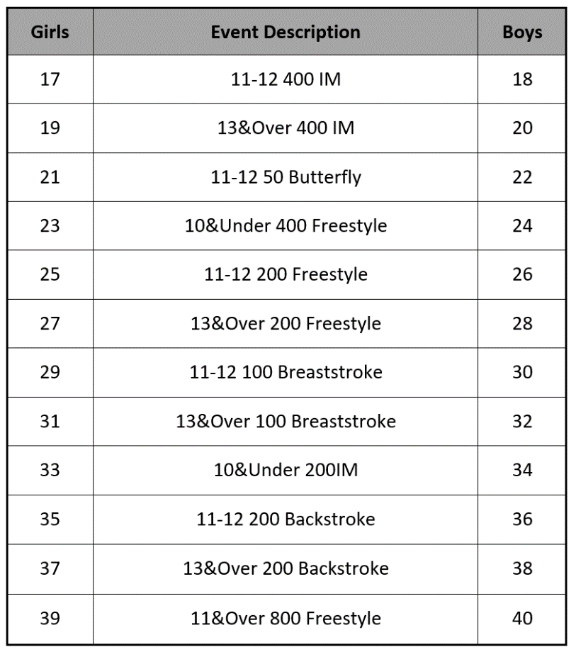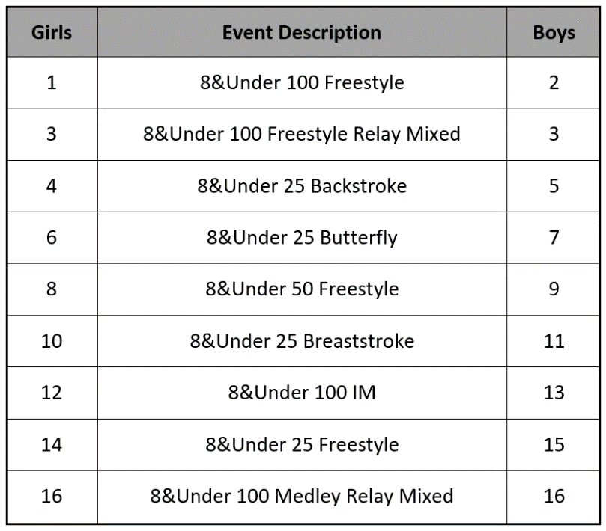

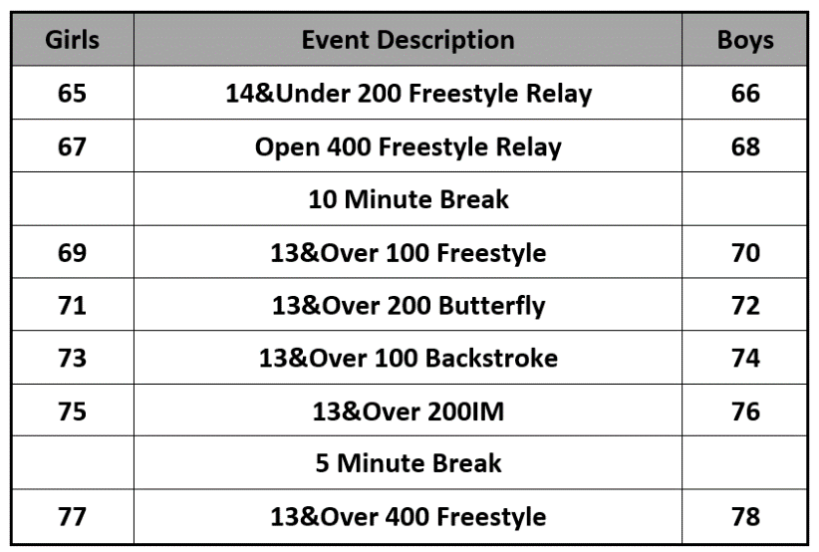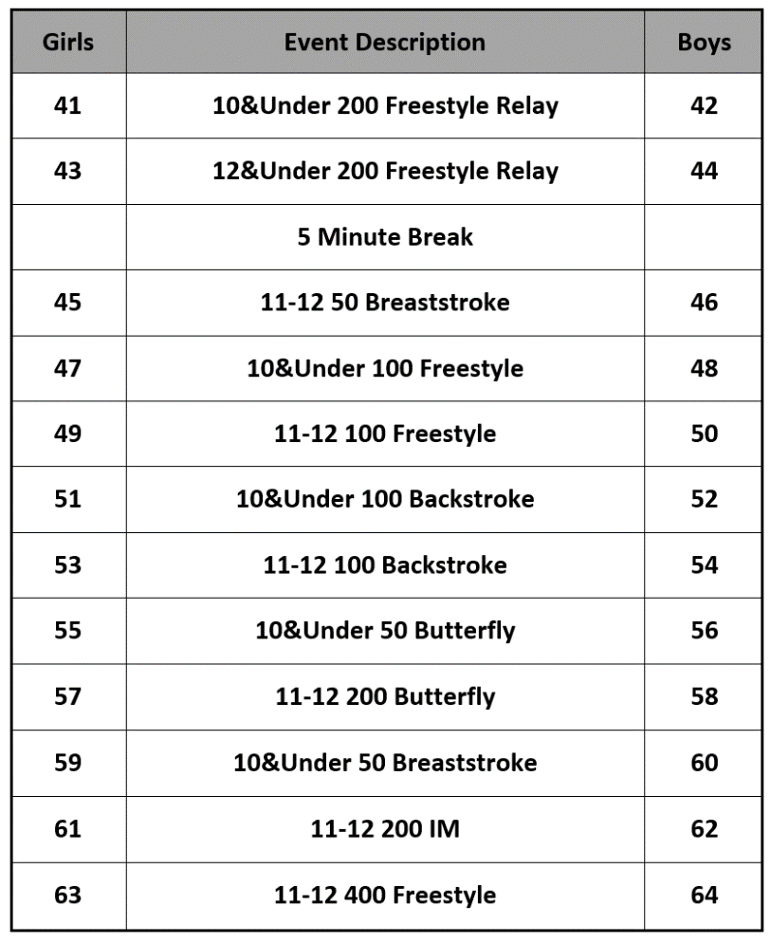 **Session 3: Saturday AM Session 4: Saturday PM**

**Session 5: Sunday AM Session 6: Sunday PM**

